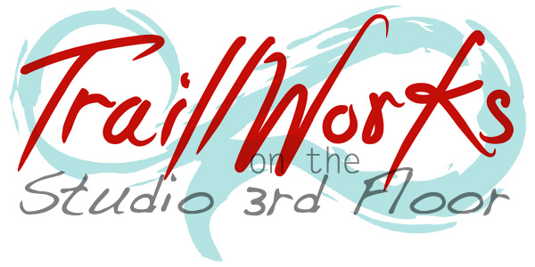
ART LESSONS at
TraillWorks

FALL SESSION enrolling soon
www.TraillWorks.com
West Orange, NJ

973.271.9104

located in the Gregory Neighborhood

Learn to Create Art with Jennie Traill Schaeffer, award-winning teaching artist and owner of TraillWorks at her professional, nurturing studio on the 3rd Floor of her West Orange, NJ home.

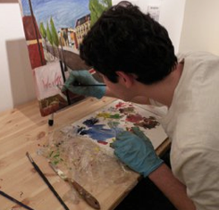
View The Student Artwork Album On Facebook
What I offer
Private and Small Group Art Lessons
Portfolio Development

Ages
Children, Teens, Adults

Individualized Approach
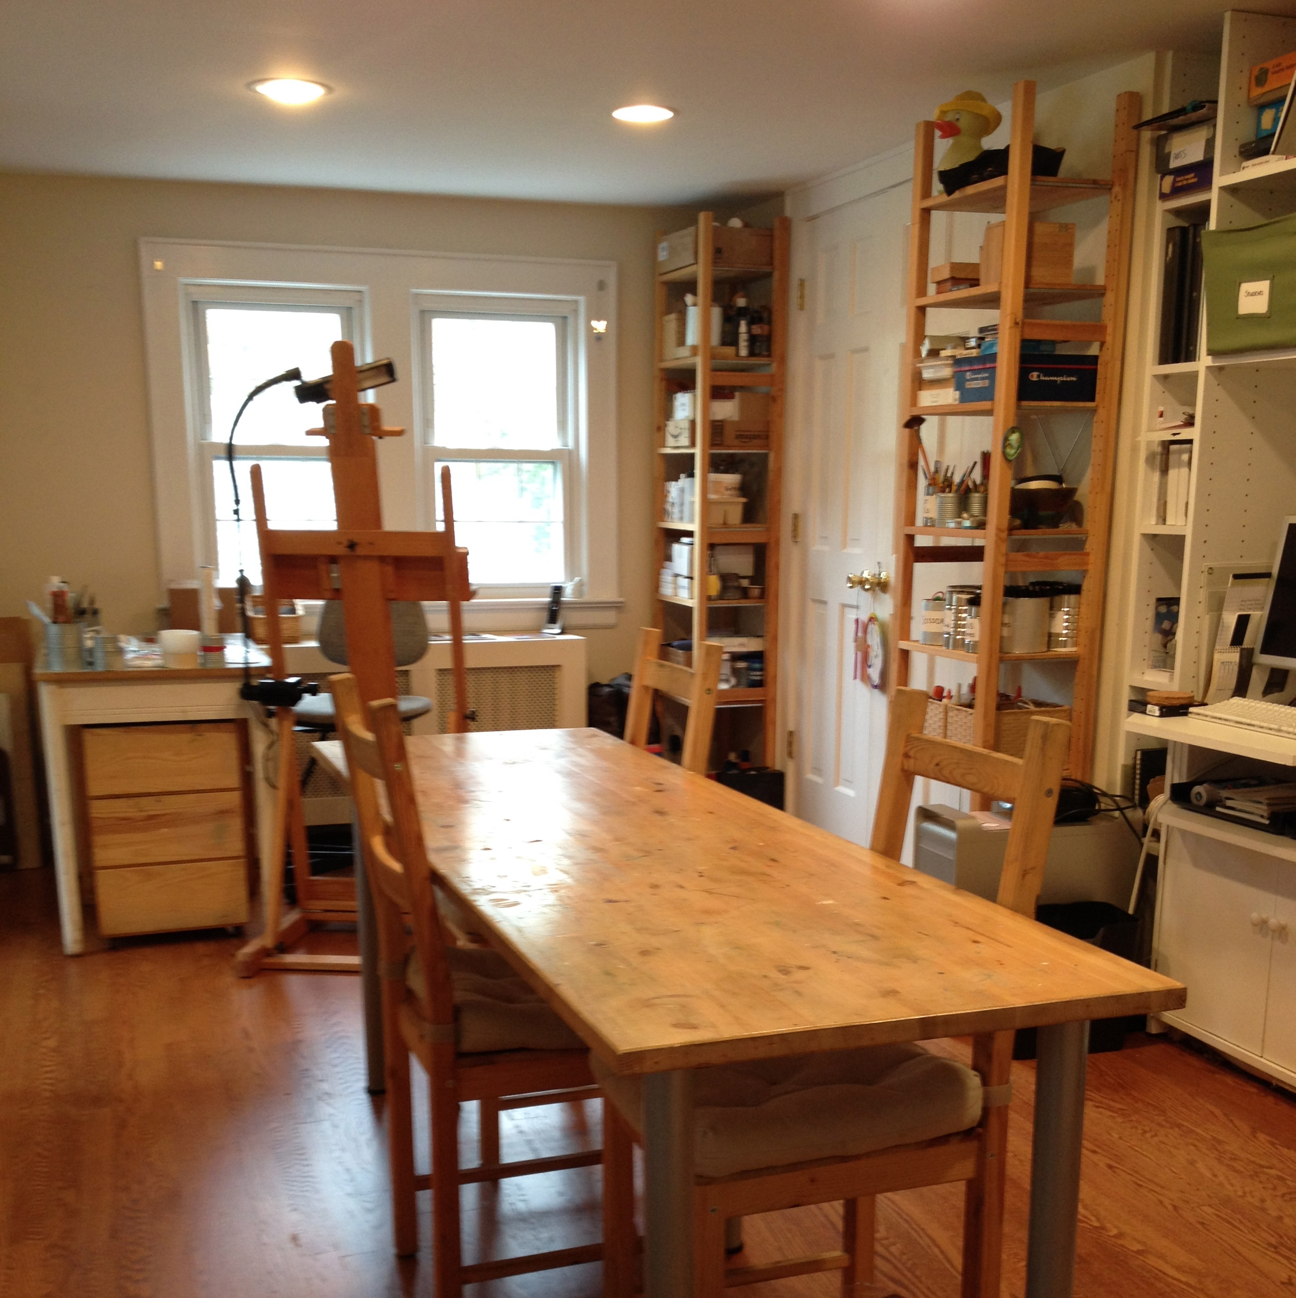
Through a multimedia, individualized approach that emphasizes strong technique, creative brainstorming, and historical context students are given the opportunity to explore and deepen their own understanding of art making. Jennie trains her students first to see and then to handle their materials, allowing for the refined creation of a variety of representational, conceptual and imaginative work.

Curriculum
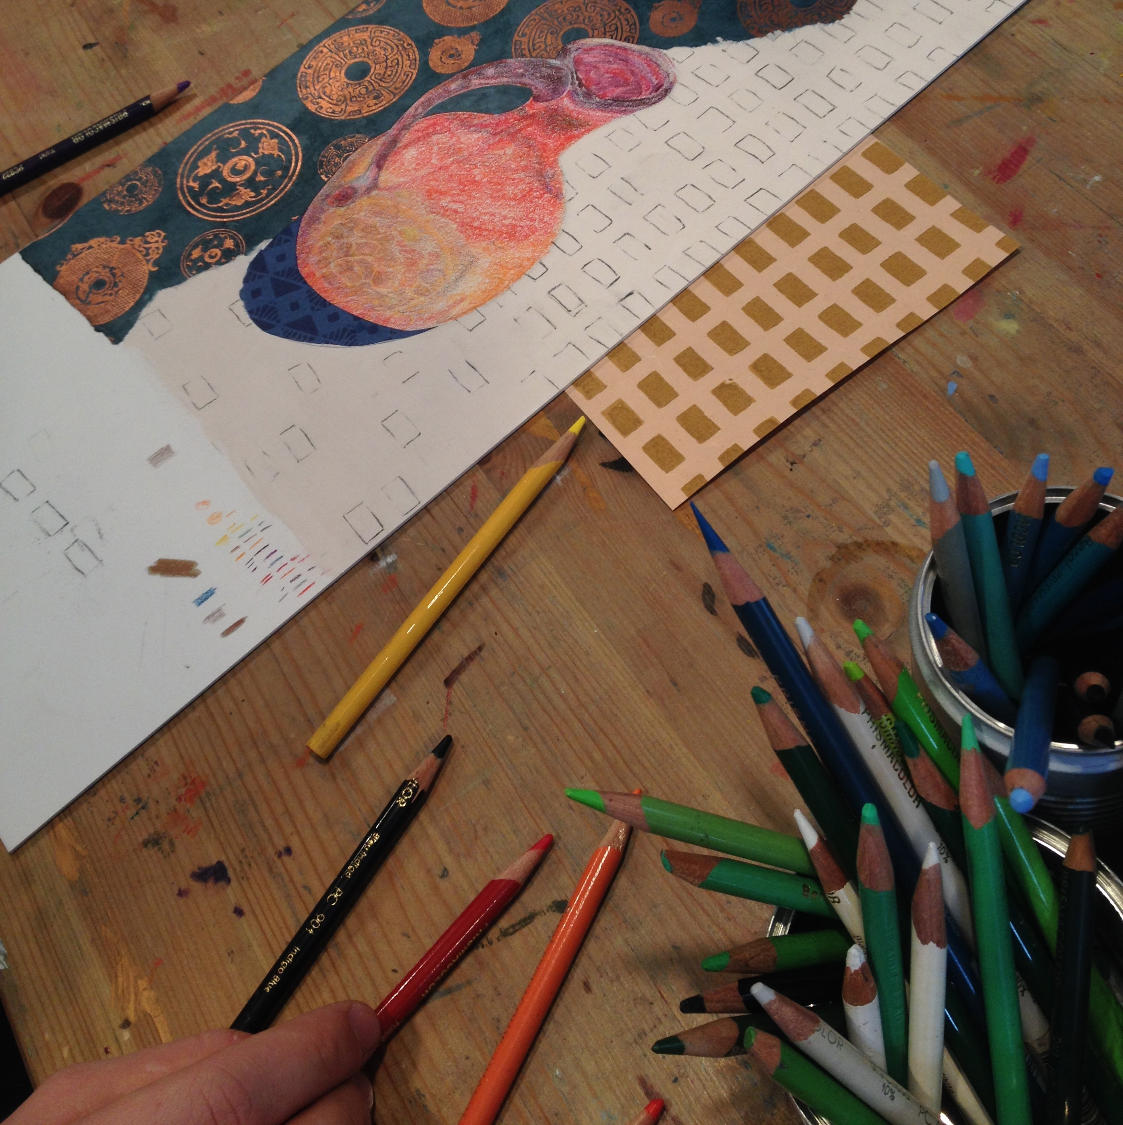
While children will be taught a more general curriculum with a broad exposure to many different media, themes, styles, and approaches, teen and adult study will be more narrowly focused on an individual basis. Students considering art school in the future can work independently with Schaeffer on developing and refining their portfolio. Adults may choose a particular discipline or style within which to work, or elect to choose a broader approach to their art education. While Schaeffer’s background is grounded in drawing and painting, her exposure to printmaking, ceramics, photography, and design provide her students opportunities to work in a variety of directions.
If you’re looking for a studio to seriously nurture or evolve your artistic pursuits or your children’s, you've found the right place. Please call Jennie at 973.271.9104 or email her at lessons@traillworks.com.

FALL 2015 Schedule & Tuition – TENTATIVE

CLASS OFFERINGS: DAYS & TIMES
TIME | Mon | Tues | Wed | Thurs | Fri | Sat
9:30 – 10:30 | Open | Adult JUMPSTART  (9:30 – 11) | Open | Open | Open
10:30 – 11:30 | Open |  | Open | Open | Open | Teen Portfolio Group  (9:30 – 11:30)
11 – 12pm | Open | Open | Open | Open | Open
1 - 2pm | Open | Open | Open | Open | Open
2 - 3pm | Open | Open | Open | Open | Open
4 - 5pm |  | Open | Open | Open
5 - 6pm |  | Open | Open | Open
SESSION SCHEDULE
Tuition Due for Monthly Payers
TIME | Mon | Tues | Wed | Thurs | Fri | Sat
Week 1 | 9/21 | 9/22 | 9/16 | 9/17 | 9/18 | 9/12
Week 2 | 9/28 | 9/29 | 9/30 | 9/24 | 9/25 | 9/19
Week 3 | 10/5 | 10/6 | 10/7 | 10/1 | 10/2 | 9/26
Week 4 | 10/12 | 10/13 | 10/14 | 10/8 | 10/9 | 10/3
Tuition Due for Monthly Payers
Week 5 | 10/19 | 10/20 | 10/21 | 10/15 | 10/16 | 10/10
Week 6 | 10/26 | 10/27 | 10/28 | 10/22 | 10/23 | 10/17
Week 7 | 11/2 | 11/3 | 11/4 | 10/29 | 10/30 | 10/24
Week 8 | 11/9 | 11/10 | 11/11 | 11/12 | 11/13 | 10/31
Tuition Due for Monthly Payers
Week 9 | 11/16 | 11/17 | 11/18 | 11/19 | 11/20 | 11/21
Week10 | 11/23 | 11/24 | 12/2 | 12/3 | 12/4 | 12/5
Week11 | 11/30 | 12/1 | 12/9 | 12/10 | 12/11 | 12/12
Week12 | 12/7 | 12/8 | 12/16 | 12/17 | 12/18 | 12/19

*No Classes or Workshops:
9/23, 11/14, 11/25 – 11/28

SCHEDULE:

Lessons are generally scheduled for one-hour sessions, once a week, but should interest exist in extended time, 1½ hour and 2 hour sessions are available. You should choose a time slot / appropriate age group from our schedule below. If your age group is not represented or a time slot isn't available that suits your schedule, please contact us as we may have students on a wait-list to get a group started. With interest and enrollment I will add more to the schedule.

TUITION & FEES:
Small Group (2 – 4) – price is per student
Duration | Weekly Rate | 4 Week Prepay | 8 Week Prepay | 12 Week Prepay
1 HOUR | $32 | $125 | $220 | $310
1.5 HOUR | $48 | $185 | $330 | $465
2 HOUR | $64 | $250 | $440 | $620
Private Lessons (Individual)
Duration | Weekly Rate | 4 Week Prepay | 8 Week Prepay | 12 Week Prepay
1 HOUR | $57 | $220 | $420 | $600
1.5 HOUR | $85 | $330 | $630 | $900
2 HOUR | $115 | $440 | $820 | $1200

Registration Fee:
There is a $12 Quarterly Fee that covers supplies and materials used during lessons. This is charged at the beginning of each session, or upon enrollment, whichever occurs first:
Winter – Due January | Spring – Due April | Summer – Due June | Fall – Due September

Discounts:

EARLY BIRD SPECIAL: SAVE 10%*
on classes and workshops when you enroll with tuition and registration paid in full by August 29th.
FAMILY SPECIALS: SAVE 10%*
on classes or workshops when you enroll another family member. The 10% is only applicable to each additional member's package.
CREATE A GROUP / REFERRAL: SAVE 15%*
on your next package when you successfully enroll other student(s). You must have at minimum one other person enrolled to create a group lesson. The organizer’s lessons must be purchased directly through the studio and not online in order to receive the discount.
*Special discounts may not be combined. Any lessons qualifying for applicable discounts must be purchased directly through the studio. Contact me to apply any of these offers.

Payment Procedures:
TraillWorks operates on a monthly payment schedule, owed prior to the first session of the month. Deductions are not made for personal vacation days, illness or closings due to inclement weather. If you join us mid-month or if you know you cannot make all consecutive classes in a session, you'll pay the weekly rate until the start of the next month.
- Students paying weekly must be paid in full at the beginning of the first class, and subsequently at the conclusion of each class.
- Students on prepay plans must be paid in full at the beginning of each package start date.
- Tuition not paid by the start of each 4-week package will be charged a $10 late fee.
- Payment may be made by cash, personal check or Visa / Mastercard / Discover / American Express.
- There is a $25 return check fee.

Scheduling:
- Most lessons are one hour in length, once per week. Private and small group lessons are available in 1 ½ and 2-hour sessions, dependent on enrollment.
- Students enrolling in small groups of 2 - 4 do so with the understanding that new students may be added at any time, without notice. It will be up to the discretion of the teacher to pair up students. If groups are mixed in age, existing students will be asked if a student of a different age level may join.
- Lessons are scheduled based on availability.

Enrollment Procedure:

Registration is accepted by email, mail or in person. Forms can be emailed to lessons@traillworks.com.

Lesson Policies

Cancellations: Classes cancelled within 24 hours cannot be rescheduled or refunded.

Refunds: Due to the intimate nature of lessons at TraillWorks, lessons are non-refundable*. Sessions must be used within the time frame of the package purchased. *The exception is when a student enrolls in a group and the group doesn’t have the enrollment to run, a refund will be made.

Make-ups:
- All students enrolled in small group lessons will be made up with other semiprivate or small groups. There is no guarantee that the student will be placed with other similar age students. Private lessons will be made up as privates.
- All make-ups must take place within the package month of the missed lesson or the lesson will be forfeited. You always have the option of scheduling a private make-up, paying the difference between the pro-rated package rate you purchased and the private weekly rate or attending open studio.
- It is the responsibility of the student to schedule makeups.

Student Behavior: TraillWorks reserves the right to dismiss any student for inappropriate behavior.

ADDITIONAL INFORMATION:

OPEN STUDIOS: Enrolled students, ages 10 and up (through adults), who wish extra time on their artwork may arrange to come to TraillWorks during open studios (see Jennie for information). Jennie will be present, but no instruction will occur. The student must be independent, taking out and cleaning up their work. Rules and schedules for signing up will be posted in the studio. This is SUBJECT to AVAILABILITY / CHILDCARE for Jennie’s kids; please ask for availability.

Sketchbooks are recommended. Helpful for keeping notes, gathering ideas, and developing your techniques at home; sketchbook assignments are often given to reinforce lessons learned in the studio. Since these are a very personal purchase, TraillWorks suggests you find one that you like. PLUS research shows doodling helps you remember better!

TraillWorks’ Pet: Jennie’s friendly dog, Ringo, will be at the studio. If you are afraid of dogs or have a concern, please discuss this with Jennie and she will work to make you comfortable (he can be crated). Her goal is to have a safe and productive learning environment.

Clothing: Please wear suitable clothing for class, i.e. clothing that can get dirty. TraillWorks is not responsible for soiled clothing.

Parking: Free on-street parking is available. Please speak to Jennie upon enrollment.
Weather: Check for closings online at www.traillworks.com or www.facebook.com/traillworks. Closures will be decided based on the West Orange Board of Education’s school closures.
Student Artwork: Student artwork left in the studio thirty days after the last session will be discarded.

